**LIST ALL FREE SYSTEM INFORMATION ABOUT THE HARDWARE AND SOFTWARE INSTALLED**

1. **Built-in System Information –**

On Windows, you can use the built-in System Information tool to view system information.

To open it, press the Windows key + R to open the Run dialog box, type "msinfo32" and press Enter. This will open the System Information window, where you can view detailed information about your hardware and software.

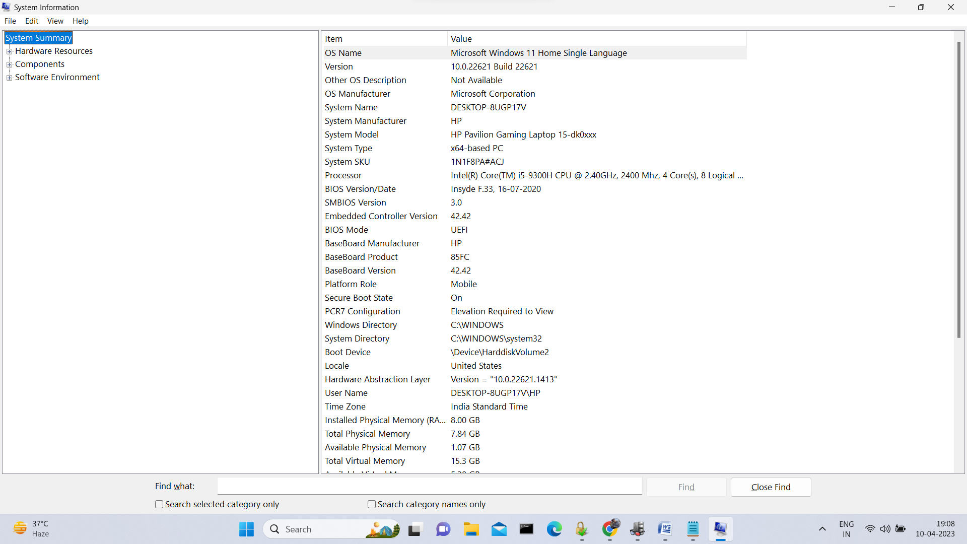

1. **Use 3rd Party App-**

Speccy is a free system information tool from CCleaner that can provide detailed information about your computer's hardware, including CPU, RAM, motherboard, graphics card, and more. You can download it from the CCleaner website.

Download and install Speccy from the CCleaner website.

Once installed, open Speccy.

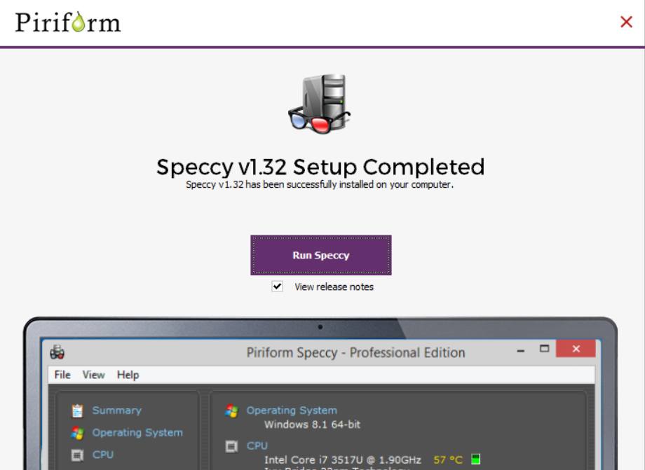

Speccy will display an overview of your system information, including your CPU, RAM, and operating system.

To view more detailed information, click on one of the categories in the left-hand pane, such as "CPU" or "RAM."

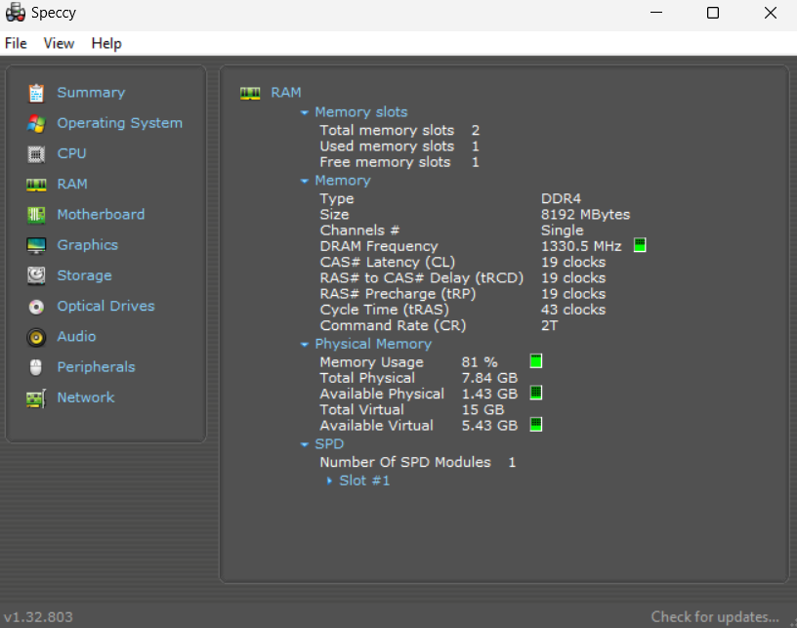

To view information about software installed on your computer, click on the "Software" category in the left-hand pane.

Speccy will display a list of installed software, including the name, version number, and publisher.

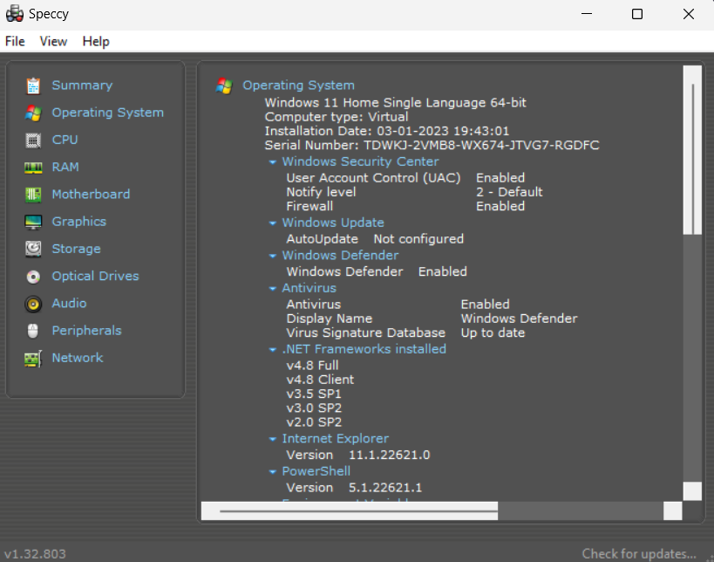

You can export the system information by clicking on the "File" menu and selecting "Save as Text."

